Module 3: Assignment 2 on Git & Jenkins

Problem Statement

You are working as a DevOps Engineer in a company named Sanders & Fresco Pvt ltd. You have been asked by your manager to create a Maven Project using Jenkins and build a war file of that project. As proof of concept, you have been given a web application to build. And once done with building the war file, deploy it over the tomcat server.

Steps to solve:

* Open Jenkins and create a Maven project using it.

* You will have to create the following jobs, which are as follows:

o Compile

o Code Review

o Unit test

o Package

o Deploy

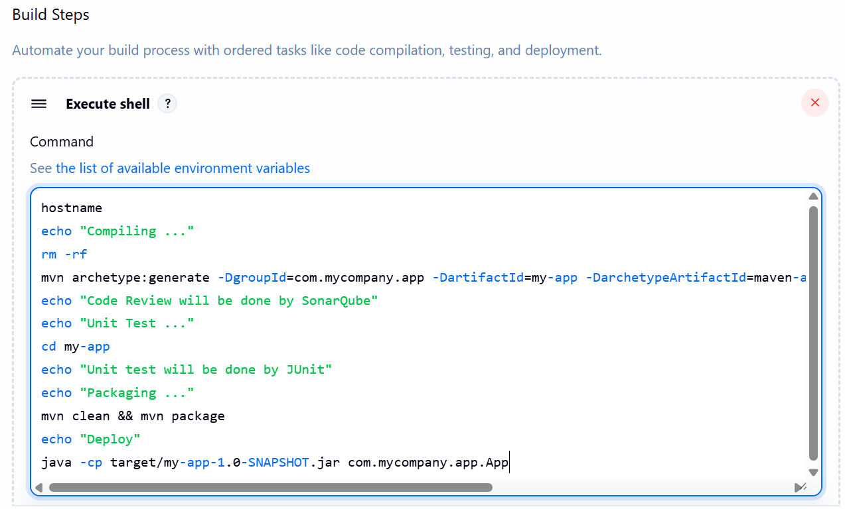

Deployment & console output: -

